**ESTIMATION OF BUSINESS EXPENSES**

1. **INTRODUCTION**

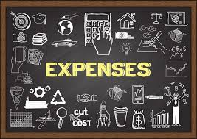

**1.1 Overview**

**Estimated Expense means the amount of the expenses which the Authority consider are properly to be incurred in the execution of the eligible works together with the amount of the costs which the Authority considers have been properly incurred or are properly to be incurred, with respect to preliminary or ancillary services and charge.**

**Business expenses are costs associated with running a company. When you know all of a company’s expenses, you can create a more accurate budget and track spending.**

**This involves estimating all the expenses required to start and operate the business, such as equipment, rent, inventory and marketing.**

**1.1 Purpose**

**Estimates are documents that provides costs for a project. Small businesses create them for potential clients so both parties are clear on the ins and outs of a project before it starts. Freshbooks has an estimates feature that help you build an estimate quickly and easily.**

**TOTAL EXPENSES = COST OF GOODS SOLD (COGS)**

**+ OPERATING EXPENSES**

**Expenses are also a part of a company’s income sheet. You must know a business’s expenses to calculate a final net profit. Costs are subtracted from revenue to** **determine a company’s taxable income**.

**2. PROBLEM DEFINITION & DESIGN THINKING**

**2.1 Empathy Map:**

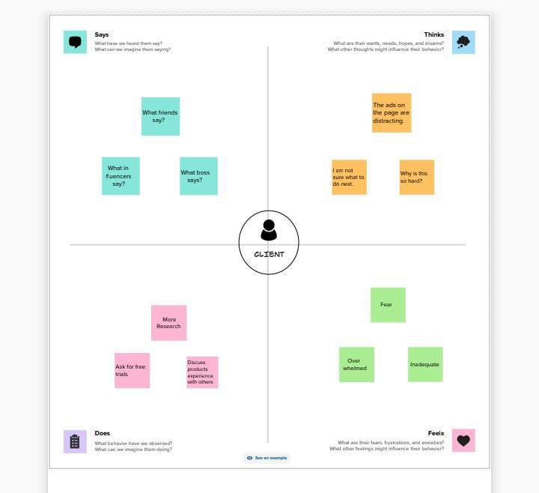

**It is a useful tool to helps teams better**

**understand their users.**

**The exercise of creating the map helps participants consider things from the users perspective along with his or her goals and challenges.**

**Then, my team are discussed and collect the details from empathy map in business expenes.**

**Next sign in and register the account for**

**Mural website and create the map.**

**2.2 Ideation & Brainstorming Map**

**Brainstorming is a helps teams to generate a large number of ideas quickly, which can be refined and merged to create the ideal solution for my team.**

**Next use the Mural website and create the map.**

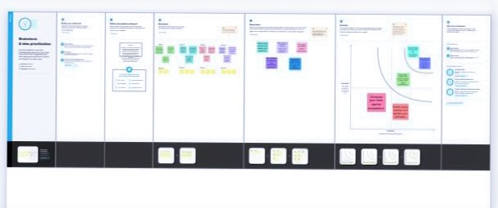

**3. RESULT**

**Data Collection & Extraction**

**Collect the dataset**

**Connect Dataset with Tableau**

**COLLECT THE DATASET:**

**My teams are collect the dataset from estimation of business expenses in online and downloading the dataset**.

**CONNECT DATASET WITH TABLEAU:**

**Installed the tableau desktop.**

**Next the insert the dataset in tableau.**

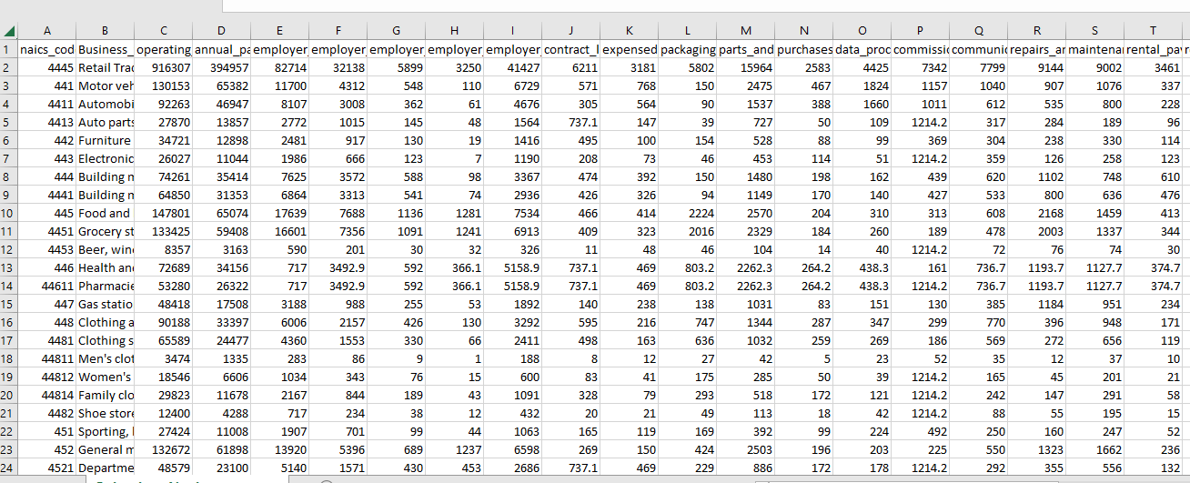

**Data Preparation**

**Prepare the Data for Visualization**

**PREPARE THE DATA FOR VISUALIZATION**

**This process helps to make the data easily understandable and ready for creating** **visualizations to gain insights into the performance and efficiency.**

**Data Visualizations**

**The process of creating graphical representations of data to help people understand and explore the information.**

**The number of unique visualizations that can be created with a given dataset.**

**There are analyse the performance and efficiency of banks include bar charts, line charts, heat maps, scatter plots, pie charts, maps etc.**

**Dashboard**

**Dashboards can be used in a variety of manufacturing, settings, such as business, finance, healthcare and many other industries.**

**Responsive and Design of dashboard**

**Once you have created views of different sheets in Tableau, you can pull them into a dashboard.**

**My teams are created the three different dashboards.**

**They are,**

**Dashboard-1**

**Expense Breakdown: Insights into Diverse Business Costs**

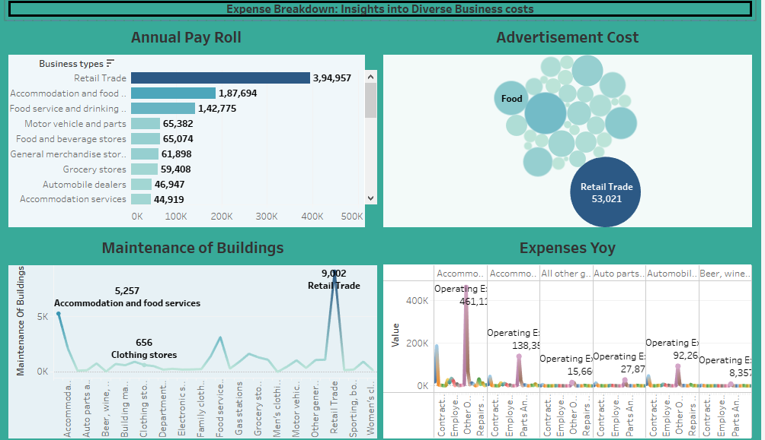

**Dashboard -2 Business Expenditure Overview**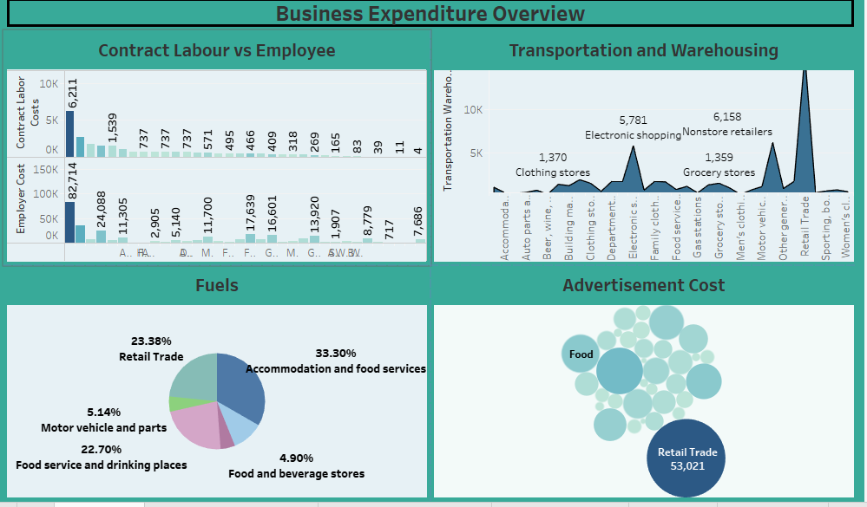

**Dashboard-3 Expenses Insights**

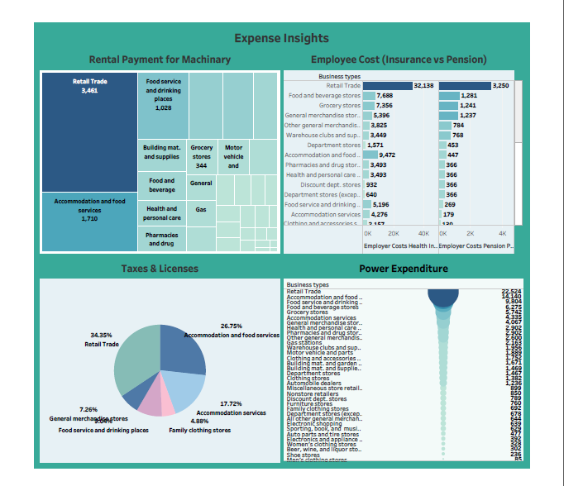

**Story**

**A storyboard is a visual representation of the data analysis process and it breaks down the analysis into a series of steps or scenes.**

**Then, my teams are created the two different story.**

**Story-1**

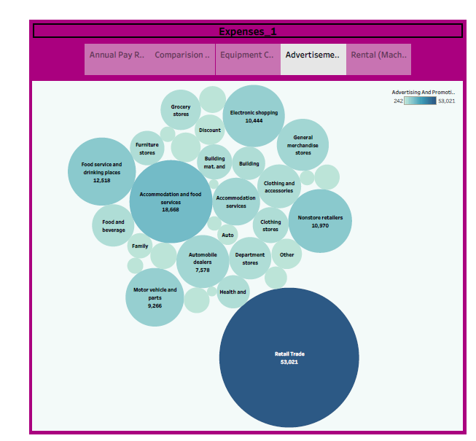

**Story-2**

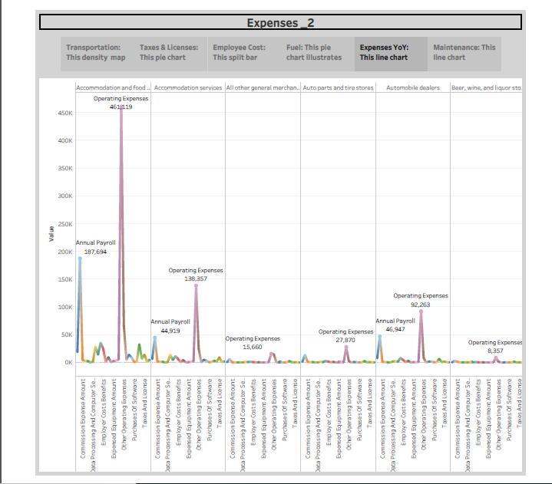

**4. ADVANTAGES & DISADVANTAGES**

**Advantages:**

* **More accurate estimations result in smooth execution of the project.**
* **Business expenses helps you understand your business’s cash flow.**
* **Learning opportunities for as a business will be involved in all aspects of your expenses.**
* **Flexibility, generally lean staffing and the ability to develop close relationships with customers are among the key benefits of business expenses.**

**Disadvantages:**

* **Financial risks in our business.**
* **Issues with stress and Health problem.**
* **Commitment to time.**
* **Risk of failure.**
* **High Competition.**

**5. APPLICATIONS**

**A business application is a collection of components that provides a business functionally that you can use internally, eternally or with other business applications. You can create business applications of individual components, which are related to each other.**

* + - * + **Keep good records.**
        + **Keep personal and business expenses separate.**
        + **Learn which expenses may be tax-deductible.**
        + **Save business travel receipts.**
        + **Record expenses as soon as possible.**
        + **Review expenses regularly.**
        + **Customer Segmentation.**
        + **Quality control and Process Improvement.**
        + **Company study the pattern of consumer behaviour through their likes and dislikes through social media, spending patterns and lifestyle.**

**6. CONCLUSION**

**In business , an estimate is a calculated guess of what something will cost.**

**Overview of my team project, Estimates are often used in bidding for contracts or projects. They can also be used to find out how much material or labor is needed for a job. 7. FUTURE SCOPE**

* **Future scope refers to the potential opportunities and prospects in a particular field, industry or career. It’s essential to consider because it helps individuals make informed decisions about their education, career and personal development.**
* **Just like a job, business too needs a lot of tie investment and huge amount of pressure to get accustomed**.

**8. APPENDIX**

**A. Source Code**

**Data set**

[**https://smartinternz.s3.amazonaws.com/Estimation_of_business_expenses.pdf**](https://smartinternz.s3.amazonaws.com/Estimation_of_business_expenses.pdf)

**Dashboard-1**

[**https://public.tableau.com/views/Dashboard1_16964808153280/Dashboard1?:language=en-US&publish=yes&:display_count=n&:origin=viz_share_link**](https://public.tableau.com/views/Dashboard1_16964808153280/Dashboard1?:language=en-US&publish=yes&:display_count=n&:origin=viz_share_link)

**Dashboard-2**

[**https://public.tableau.com/views/Dashboard2_16964818811740/Dashboard2?:language=en-US&publish=yes&:display_count=n&:origin=viz_share_link**](https://public.tableau.com/views/Dashboard2_16964818811740/Dashboard2?:language=en-US&publish=yes&:display_count=n&:origin=viz_share_link)

**Dashboard-3**

[**https://public.tableau.com/views/Dashboard3_16964830405090/Dashboard3?:language=en-US&publish=yes&:display_count=n&:origin=viz_share_link**](https://public.tableau.com/views/Dashboard3_16964830405090/Dashboard3?:language=en-US&publish=yes&:display_count=n&:origin=viz_share_link)

**Story-1**

[**https://public.tableau.com/views/Story1_16964834728950/Story1?:language=en-US&publish=yes&:display_count=n&:origin=viz_share_link**](https://public.tableau.com/views/Story1_16964834728950/Story1?:language=en-US&publish=yes&:display_count=n&:origin=viz_share_link)

**Story-2**

[**https://public.tableau.com/views/Story2_16964841705840/Story2?:language=en-US&publish=yes&:display_count=n&:origin=viz_share_link**](https://public.tableau.com/views/Story2_16964841705840/Story2?:language=en-US&publish=yes&:display_count=n&:origin=viz_share_link)

